Chapter 4, Problem 86.

A black box with a circuit in it is connected to a variable resistor. An ideal ammeter (with zero resistance) and an ideal voltmeter (with infinite resistance) are used to measure current and voltage as shown in Fig. 4.143. The results are shown in the table below.

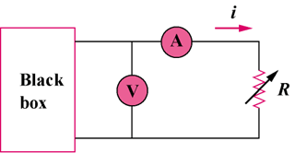

Figure 4.143
For Prob. 4.86.

- Find i when R = 4 Ω.
- Determine the maximum power from the box.

R(Ω) | V(V) | i(A)
2 | 3 | 1.5
8 | 8 | 1.0
14 | 10.5 | 0.75

